The Oconomowoc Art Department and the Roots Coffee Bar & Café are joining together for the third annual k-12th grade art show:

“Off the Wall”
Congratulations ___________________ your work of art has been selected to be exhibited in the show!

Please invite your family and friends to share this great honor with you.
Sincerely,
& the O.A.S.D Art Department
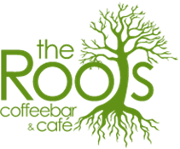
Location: 124 E Wisconsin Ave, Oconomowoc
Reception and Awards Presentation: March 22rd at 6:00
Exhibition dates: March 18th – March 28th 2016

