The Oconomowoc Art Department and the Roots Coffee bar & Café are joining together for the second annual k-12th grade art show:

“Off the Wall”
Congratulations ___________________ your work of art has been selected to be exhibited in the show!

Please invite your family and friends to share this great honor with you. Sincerely, and the O.A.S.D Art Department.
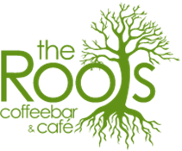
Location: 124 E Wisconsin Ave, Oconomowoc
Reception and Awards Presentation: March 23rd at 6:00
Exhibition dates: March 23rd – April 12th

