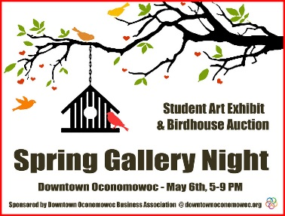

Artist:

Grade:

School:

Title:

 



Artist:

Grade:

School:

Title:

 



Artist:

Grade:

School:

Title:

 



Artist:

Grade:

School:

Title:

 



Artist:

Grade:

School:

Title:

 



Artist:

Grade:

School:

Title:

 