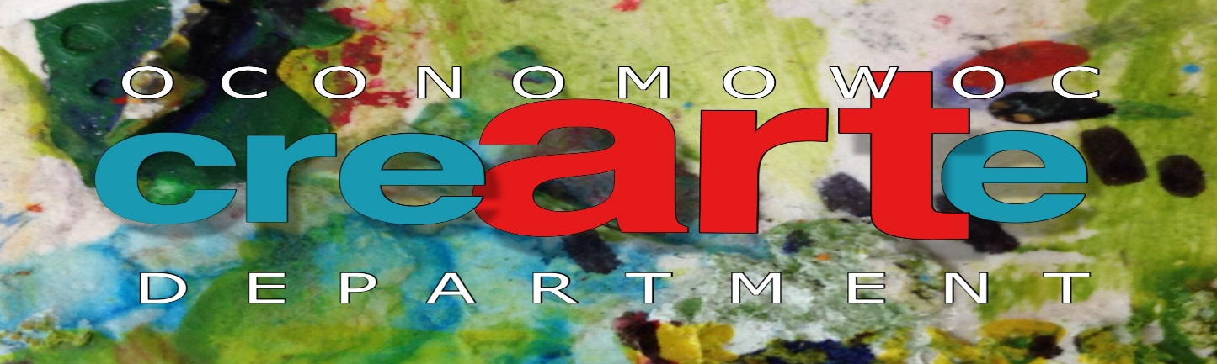

Dear Oconomowoc Businesses Participating in Exhibiting Student Art,
First, the Oconomowoc Art Department would like to thank you for exhibiting our student art for Gallery Night, May 1, 2015. Our students are so excited to showcase their art to the community and request their work is carefully taken care of during the evening. All of their art work is precious and they will want to bring it home to display for parents or may need to submit works of art for a college portfolio.
Directions for exhibiting student art:
- Place art in a safe and visible place inside of business
- Secure art so it will not break (Three dimensional work above reach and two dimensional art fastened to wall or easel)
- Place note next to the art: Please Do Not Touch Art
- Check-on the art throughout the evening to confirm that it is safe and secure
- If your business is closed during Gallery Night, May 1, 2015 you may not participate in event. Our students and parents will be invited to view their art during the event so if your business is not open they will be disappointed.
- Please contact Nicole Sussek, Oconomowoc Art Educator, if you have questions or would like further assistance with displaying art.

On behalf of the Oconomowoc School District Art Department, I would like to thank you again for encouraging the artistic talents of our students and being a good steward of the amazing art our students created during Gallery Night.
With gratitude,

Nicole Sussek
Oconomowoc Art Department
Cell phone number: ???

