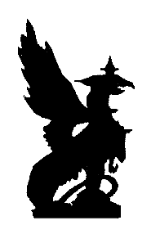Dear

### Congratulations your work of art has been selected to be exhibited at the annual Oconomowoc Festival of the Arts, **August 15th and 16th, 2015,**

### **10 am – 5 pm.**

Your artwork will be displayed by the entrance of the park along with other student art from Oconomowoc School District so invite your family and friends to view your masterpiece!

### Bravo,

### Mr. Stuckey and Ms. La Grange Visit Summit’s Student Art Gallery

<http://oconomowocarts.org/>

Location of

Oconomowoc

Student Art Exhibit